**Assignment 9**

I would recommend everybody to solve this assignment to get bonus points .

These are also the type of question I would be asking for Final Exams. So be prepared with your Excel or R.

12.34

12.54 (Dandruff dataset- Both a and b can be solved together running the ANOVA Single Factor(Group by Columns) in Excel or R)

13.43 (Plants1 dataset- Use ANOVA with Replication with number of rows = 9)

**12.34 Do labels matter?**

A study was performed to examine the self-identification of college students of Asian descent with various identity categories and assess whether there are attitudinal differences across these categories. Undergraduates at a large midwestern university who had identified themselves as being of Asian descent on their admission application were asked to participate in the study.12 A total of 620 undergraduates filled out the survey. One question classified the participants into groups by asking them to indicate the option with which they primarily identify: (a) Asian American, (b) specific ethnicity (for example, Chinese), (c) ethnicity American (for example, Chinese American), and (d) other. The responses to the remaining survey items were then compared across these four groups. One item was “The campus is supportive of Asian American students.” Responses were on a four-point scale (1 = strongly disagree, 4 = strongly agree). A summary of the results follows:

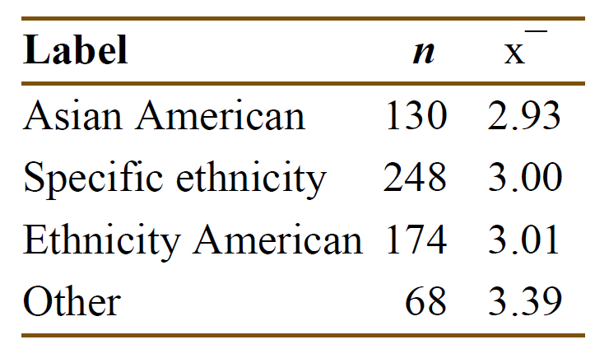

(a) What are the numerator and denominator degrees of freedom for the *F* test?

(b) Using the formula on page 661 and the preceding results, calculate SSG.

(c) Given SSE = 797.25, use your result from part (b) to compute the *F* statistic.

(d) Compute the *P*-value and state your conclusions.

(e) Without doing any additional analysis, describe the pattern in the means that is likely responsible for your conclusions in part (d).

**12.54 A dandruff study.**

Analysis of variance methods are often used in clinical trials where the goal is to assess the

effectiveness of one or more treatments for a particular medical condition. One such study compared three treatments for dandruff and a placebo. The treatments were 1% pyrithione zinc shampoo (PyrI), the same shampoo but with instructions to shampoo two times (PyrII), 2% ketoconazole shampoo (Keto), and a placebo shampoo (Placebo). After six weeks of treatment, eight sections of the scalp were examined and given a score that measured the amount of scalp flaking on a 0 to 10 scale. The response variable was the sum of these eight scores. An analysis of the baseline flaking measure indicated that randomization of patients to treatments was successful in that no differences were found between the groups. At baseline there were 112 subjects in each of the three treatment groups and 28 subjects in the Placebo group. During the clinical trial, 3 dropped out from the PyrII group and 6 from the Keto group. No patients dropped out of the other two groups.

**DANDRUFF**

(a) Find the mean, standard deviation, and standard error for the subjects in each group. Summarize these, along with the sample sizes, in a table and make a graph of the means.

(b) Run the analysis of variance on these data. Write a short summary of the results and your

conclusion. Be sure to include the hypotheses tested, the test statistic with degrees of freedom, and the *P*-value.

**13.43 A comparison of plant species under low water conditions.**

The PLANTS1 data file gives the percent of nitrogen in four different species of plants grown in a laboratory. The species are *Leucaena leucocephala*, *Acacia saligna*, *Prosopis juliflora*, and

*Eucalyptus citriodora*. The researchers who collected these data were interested in commercially

growing these plants in parts of the country of Jordan where there is very little rainfall. To examine the effect of water, they varied the amount per day from 50 millimeters (mm) to 650 mm in 100 mm increments. There were 9 plants per species-by-water combination. Because the plants are to be used primarily for animal food, with some parts that can be consumed by people, a high nitrogen content is very desirable. **PLANTS1**

(a) Find the means for each species-by-water combination. Plot these means versus water for the four species, connecting the means for each species by lines. Describe the overall pattern.

(b) Find the standard deviations for each species-by-water combination. Is it reasonable to pool the standard deviations for this problem? Note that with sample sizes of size 9, we expect these standard deviations to be quite variable.

(c) Run the two-way analysis of variance. Give the results of the hypothesis tests for the main effects and the interaction.